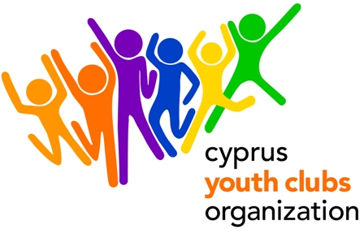
Youth in Action, Action 2 - European Voluntary Service
Enhancing Awareness in European Diversity

PROJECT OUTLINE
- Project title: Enhancing Awareness in European Diversity
- Organization: Cyprus Youth Clubs Organization (CYCO)
- Main theme for the project: Awareness raise regarding European values, projects and opportunities as well as understanding and assimilating different European cultures.
- Project type: Youth in Action, Action 2 - European Voluntary Service
- Number of volunteers: 2
- Organizations’ Country: Cyprus
- The project starts: March 1 2012
- The project ends: September 1 2012
- Deadline for applications: 21 October 2011
- Duration: 6 months
- Group age (average): 18- 30
- Contact person: Kafkalias Giorgos
- E-mail: giorgos.kafkalias@cyco.org.cy
- Tel.: +35722323260
- Fax: +35722321979
- Summary of the project:
“Enhancing Awareness in European Diversity” is going to be an educational project clearly aiming at disseminating certain skills and awareness about European citizenship and youth participation. The volunteers will support local volunteers who are familiar with the specific local needs, such as youth leaders and young volunteers. Volunteers will gather European documentation and will produce informational material. They will also support the European Projects & International Relations Coordinator in certain tasks as database update, communication, event and training organizing, helping youth clubs in partners search, facilitating events, promoting the Youth in Action Programme, promoting the EU values, key priorities, opportunities, etc. The volunteers will receive mentoring from the European Projects & International Relations Coordinator of the CYCO. They will also have the chance to learn more about Cyprus, about culture and mentality of people and in general enhance their awareness on European Diversity.
In the end of their service they will receive a certificate and recommendation letter (s).

- Financial aspects: participants will be reimbursed for the 90% of the travel cost. Accommodation, food and insurance will be covered by CYCO.

- How to participate:
FOR THE ORGANISATION: After you fill in the Part 3 of the 2010 application, send the scanned version to Giorgos Kafkalias at giorgos.kafkalias@cyco.org.cy and mail the original to
GIORGOS KAFKALIAS, CYPRUS YOUTH CLUBS ORGANIZATION
Platia Iroon 1, Ag. Mamas, Lakatamia, 2330, CUPRUS
PLEASE EMAIL ME THE ORGANISATION’S EVS ACCREDITATION NUMBER (KNOWN AS EI NUMBER).
FOR THE VOLUNTEERS: Fill in the Standard Application Form attached and send us a C.V (if available) to Giorgos Kafkalias giorgos.kafkalias@cyco.org.cy

